This set of Cloud Computing Multiple Choice Questions & Answers (MCQs) focuses on “Hypervisors – 1”.

1. Which type of Hypervisor is shown in the following figure?  
[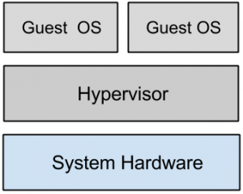](https://www.sanfoundry.com/wp-content/uploads/2015/10/cloud-computing-questions-answers-hypervisors-1-q1.png)  
a) Type 1  
b) Type 2  
c) Type 3  
d) All of the mentioned  
View Answer

Answer: a  
Explanation: A hypervisor running on bare metal is a Type 1 VM or native VM.

2. Point out the wrong statement.  
a) Load balancing virtualizes systems and resources by mapping a logical address to a physical address  
b) Multiple instances of various Google applications are running on different hosts  
c) Google uses hardware virtualization  
d) All of the mentioned  
View Answer

Answer: c  
Explanation: Google performs server load balancing to distribute the processing load and to get high utilization rates.

3. Which of the following is another name for the system virtual machine?  
a) hardware virtual machine  
b) software virtual machine  
c) real machine  
d) none of the mentioned  
View Answer

Answer: a  
Explanation: Some virtual machines are designed to run only a single application or process and are referred to as process virtual machines.

4. Which of the following provide system resource access to virtual machines?  
a) VMM  
b) VMC  
c) VNM  
d) All of the mentioned  
View Answer

Answer: a  
Explanation: VMM is another name for Hypervisor.

5. Point out the correct statement.  
a) A virtual machine is a computer that is walled off from the physical computer that the virtual machine  
is running on  
b) Virtual machines provide the capability of running multiple machine instances, each with their own operating system  
c) The downside of virtual machine technologies is that having resources indirectly addressed means there is some level of overhead  
d) All of the mentioned  
View Answer

Answer: d  
Explanation: This makes virtual machine technology very useful for running old versions of operating systems, testing applications in what amounts to a sandbox.

**Take Cloud Computing Mock Tests - Chapterwise!  
Start the Test Now:**[**Chapter 1,**](https://rank.sanfoundry.com/cloud-computing-mock-test-1/)[**2,**](https://rank.sanfoundry.com/cloud-computing-mock-test-2/)[**3,**](https://rank.sanfoundry.com/cloud-computing-mock-test-3/)[**4,**](https://rank.sanfoundry.com/cloud-computing-mock-test-4/)[**5,**](https://rank.sanfoundry.com/cloud-computing-mock-test-5/)[**6,**](https://rank.sanfoundry.com/cloud-computing-mock-test-6/)[**7,**](https://rank.sanfoundry.com/cloud-computing-mock-test-7/)[**8,**](https://rank.sanfoundry.com/cloud-computing-mock-test-8/)[**9,**](https://rank.sanfoundry.com/cloud-computing-mock-test-9/)[**10**](https://rank.sanfoundry.com/cloud-computing-mock-test-10/)

6. An operating system running on a Type ______ VM is full virtualization.  
a) 1  
b) 2  
c) 3  
d) All of the mentioned  
View Answer

Answer: a  
Explanation: Because it is a complete simulation of the hardware that it is running on.

7. Which of the following is Type 1 Hypervisor?  
a) Wind River Simics  
b) Virtual Server 2005 R2  
c) KVM  
d) LynxSecure  
View Answer

Answer: d  
Explanation: Type 1 VMs have no host operating system because they are installed on a bare system.

8. Which of the following is Type 2 VM?  
a) VirtualLogix VLX  
b) VMware ESX  
c) Xen  
d) LynxSecure  
View Answer

Answer: c  
Explanation: Xen is used by Amazon Web Services to provide Amazon Machine Instances (AMIs).

9. Which of the following will be the host operating system for Windows Server?  
a) VirtualLogix VLX  
b) Microsoft Hyper-V  
c) Xen  
d) All of the mentioned  
View Answer

Answer: b  
Explanation: Type 2 virtual machines are installed over a host operating system.

10. Which of the following should be placed in second lowermost layer for the following figure?  
[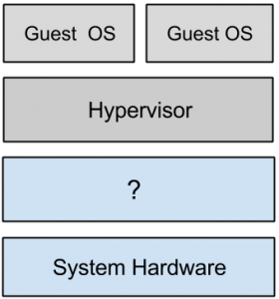](https://www.sanfoundry.com/wp-content/uploads/2015/10/cloud-computing-questions-answers-hypervisors-1-q10.png)  
a) Host Operating System  
b) Software  
c) VM  
d) None of the mentioned  
View Answer

Answer: a  
Explanation: Examples of Type 2 Virtual Machine Monitors are Containers, KVM, Microsoft Hyper V and Parallels Desktop for Mac.